


FRAMEWORK HOUSING ASSOCIATION
Tenant Satisfaction Measures – Summary of Approach 2025/26

Table of Contents

Introduction 3

Summary of Achieved Sample & Sample Method 3

Timing of Survey 4

Collection Method(s) 4

Sample Method 4

Representativeness 5

Questionnaire 7

Introduction

The Tenant Satisfaction Measures (TSM) Standard mandates that all registered providers develop and report TSMs in accordance with the guidelines set by the regulator. As part of this requirement, it is necessary for Framework Housing Association to inform its customers about its approach to conducting the TSM Perception survey and collecting data.
This document details Framework methodology and outlines the criteria specified in the Regulator of Social Housing’s publication, Tenant Satisfaction Measures Return.
The Tenant Satisfaction Measures (TSM) Standard requires all registered providers to conduct tenant perception surveys and report performance annually as specified by the RSH. TSMs are intended to make landlords’ performance more visible to tenants so that tenants can hold their landlord to account. TSMs consist of 22 measures: 10 providing management information from data held by the landlord and 12 satisfaction measures gathered from tenant surveys. In addition to overall satisfaction with landlord services, the measures cover five key themes:
- Keeping properties in good repair
- Maintaining building safety
- Respectful and helpful engagement
- Responsible neighbourhood management
- Effective handling of complaints
Providers must publish a summary of the survey approach used to generate published tenant perception measures. This must be made clearly available alongside each set of tenant perception measures published by the provider.

Summary of Achieved Sample & Sample Method

Framework works with Acuity Research & Practice Ltd, an accredited organisation that is dedicated to providing research services in the social housing sector. We use survey information to understand how our tenants feel about their homes and services and how we can improve. Acuity was commissioned for collecting, generating and validating reported perception measures.
In 2025/26, Framework completed TSM surveys as a census. The sample size was chosen to ensure that the level of statistical accuracy set out by the Regulator of Social Housing was met. Framework must ensure that they survey enough residents to meet a statistical accuracy (margin of error at 95% confidence interval) of +/- 5%.
During 2025/26, Framework completed 631 TSM surveys. Framework have 1425 properties which means that a statistical accuracy level of +/- ±2.7% was achieved, which is a greater level of accuracy than required.
No tenant was removed from the sample frame.
10x £30 (shopping vouchers)

Timing of Survey
Framework carried out a total of 631 surveys between 25/09/2025 and 14/01/2026


Collection Method(s)

The TSM Surveys were completed via postal methodology. The rationale for using a mixed methodology approach is:

- Accessibility and Inclusivity: Ensuring accessibility for all tenants, which aligns with our goal of reaching a broad and representative sample
- Engagement and Data Quality: Indirect interaction by paper allows participants to answer clarifying questions and leading to more accurate and detailed responses. This is particularly valuable for nuanced satisfaction metrics. However, every postal survey includes a unique QR Code and hyperlink with unique respondent code so that the participant can complete the survey online should they prefer to do so.
- Reliability and Consistency: Maintaining consistency with previous years’ methodologies allows for more reliable trend analysis. It also enables richer information to be gathered.
- Independence: Using Acuity, an independent market research agency, means that participants are free from influence from the rest of the organisation.

Sample Method

A census approach was used for Framework‘s fieldwork. Acuity sent a postal survey to all tenants. All the tenants had the opportunity to complete the survey online by using the QR code/hyperlink provided on the cover letter in the postal survey pack. The survey is carefully scripted to ensure a professional and consistent process.
Survey responses are immediately shared with Framework, who then manage a follow up and review process which includes both responding to feedback as necessary, and analysing the feedback, to understand how we can improve.

Representativeness

The final survey data was weighted on Accommodation Type to ensure that the survey was representative of the tenant population as a whole. The characteristics by which representativeness was determined were:

Accommodation Type | Population | Sample
Care Home | 0% | 0%
Dispersed Self Contained | 41% | 46%
Dispersed Shared | 13% | 13%
Hostel Room | 4% | 2%
Hostel Self Contained | 5% | 5%
Staffed Self Contained | 37% | 34%

Length of Tenancy | Population | Sample
< 1 year | 61% | 59%
1 - 3 years | 33% | 37%
4 - 5 years | 2% | 2%
6 - 10 years | 1% | 1%
11 - 20 years | 2% | 0.79%
Over 20 years | 0.07% | 0%

Age Group | Population | Sample
0 - 24 | 24% | 23%
25 - 34 | 19% | 19%
35 - 44 | 23% | 26%
45 - 54 | 18% | 19%
55 - 59 | 5% | 5%
60 - 64 | 3% | 3%
65 - 74 | 2% | 2%
75 - 84 | 0.14% | 0%
85 + | 0.14% | 0.16%
Unknown | 6% | 4%

Questionnaire & Introductory Text


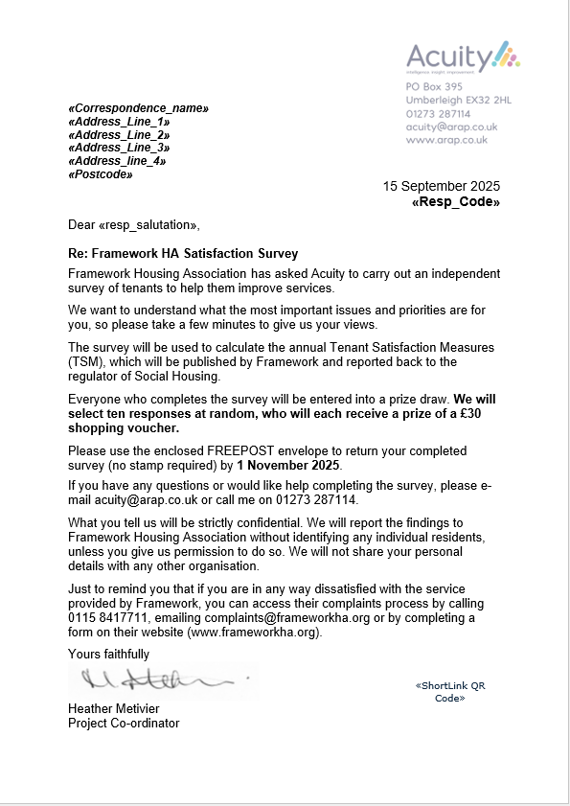
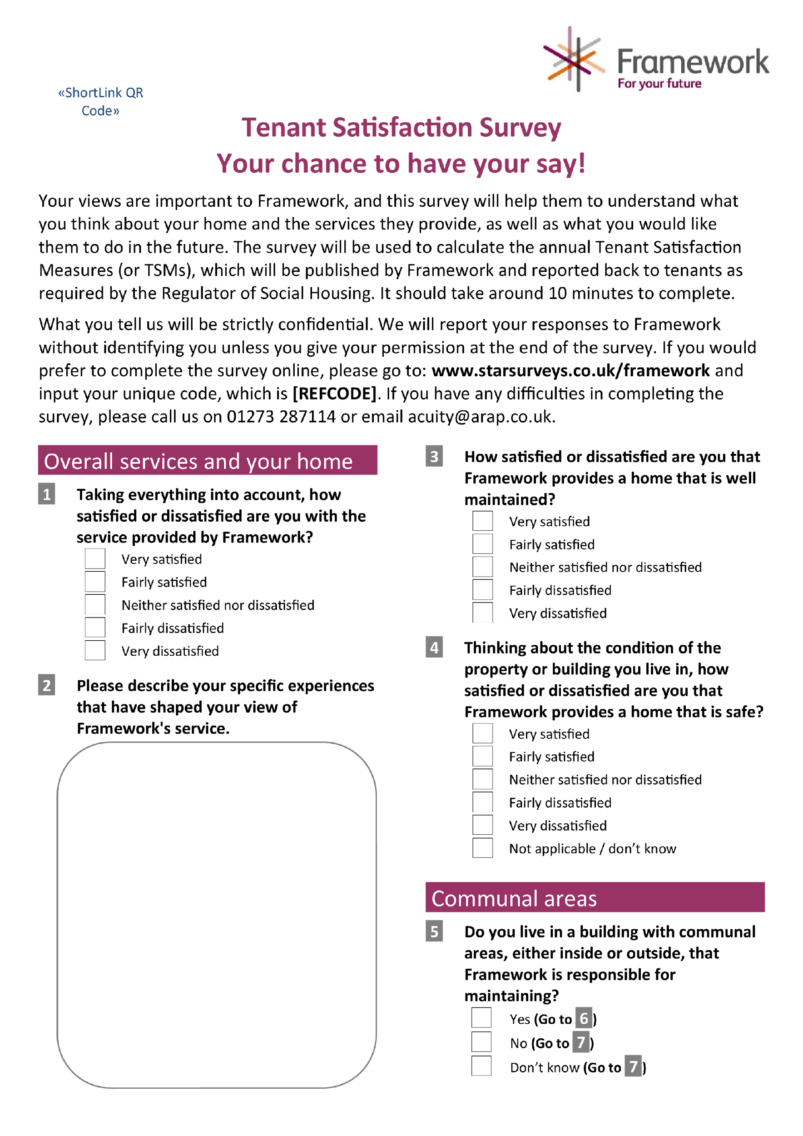 | 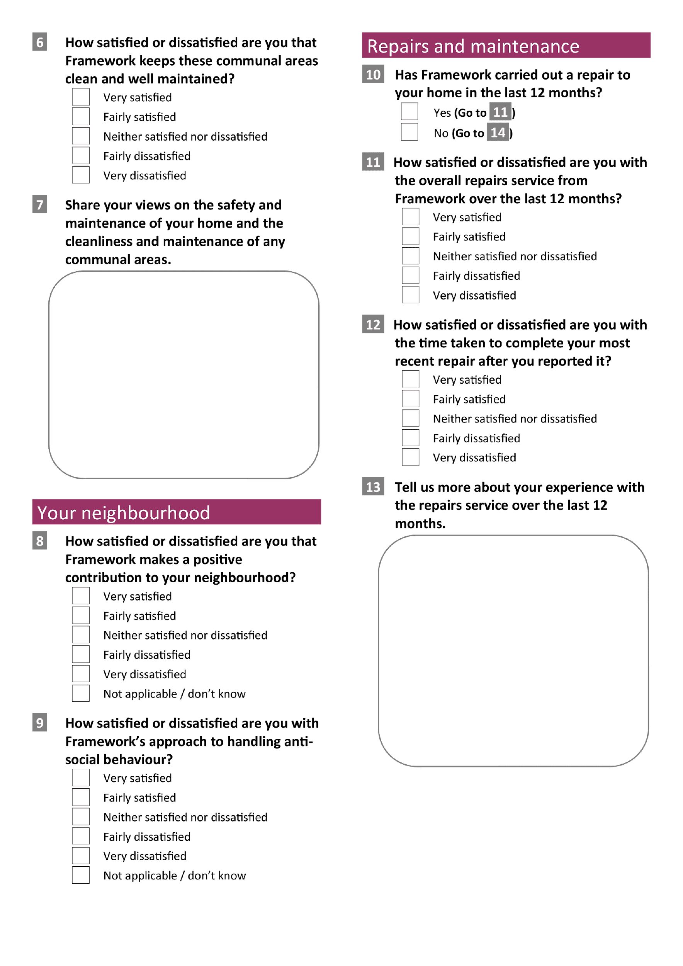
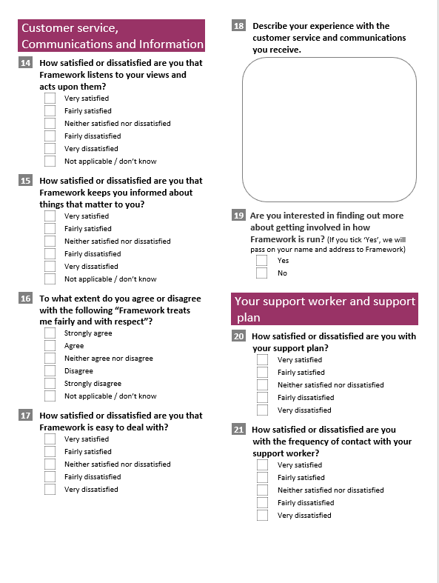 | 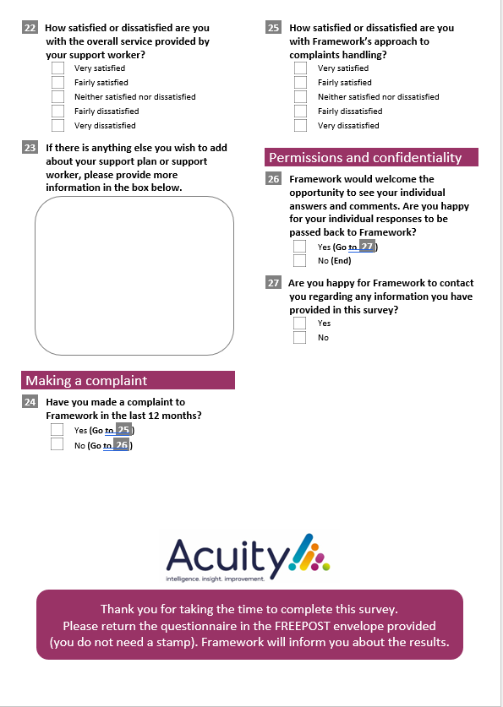

Report by Acuity Research & Practice

01273 287114
acuity@arap.co.uk

