Written Statement for Framework’s 2026 Gender Pay Gap Report

I confirm that to the best of my knowledge and belief, the 2026 Gender Pay Gap Information that has been submitted by Framework, is accurate.
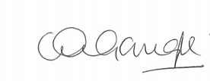
Claire McGonigle
Deputy Chief Executive, Framework
DATE March 2026

