Research Summary:
Readiness for change in people living with Severe and Multiple Disadvantage
Researchers:

Alex Barston¹, Anna Tickle^{2,3}, Sophie Buckley¹ & Laura Hancox²
¹University of Lincoln, ²University of Nottingham, ³Framework
What was this research about?

- There are some theories about ‘readiness to change’ – the idea that to make positive changes in their life, a person has to be ‘ready’. The most famous is the ‘stages of change’ model. This says that people move from not thinking about change at all, to thinking about it, to changing their behaviour, to keeping the changes going, and sometimes to ‘relapse’. The cycle then begins again.

- Sometimes services (mental health, substance use, housing and others) use the idea that somebody is ‘not ready to change’ to exclude them from a service. When this happens, the person is not usually offered support to become more ready for change.

- The stages of change model usually focuses on one change only, e.g. smoking or substance use. For people facing Severe and Multiple Disadvantage¹ (SMD), recovery may take lots of changes: mental health and substance use recovery, finding and keeping accommodation, and reducing offending. It will often need a person to change how they see themselves and other people. They might need to leave some relationships or friendships and make new support networks too. The stages of change model does not account for so much change.

- No research had been done to ask people facing SMD what they think ‘readiness to change’ means or how it happens. Hearing the views of people who have experienced SMD is vital to understand these experiences and how services can help.

- This research aimed to work with people facing SMD to develop a new theory about how readiness for change develops for them.

What did we do?

- We interviewed 12 people experiencing SMD; 10 men and 2 women; 10 identified as White and two as mixed White and Black Caribbean. All 12 were or had recently been homeless, and all had ongoing drug or alcohol use and mental health problems.

- about how they understand ‘readiness to change’. We asked them about what it means to them and how readiness to change can grow when facing SMD.

- We analysed what they said to develop a new theory. We used an approach called ‘grounded theory’, which builds theory based closely on what people have said.

What did we find?

To start with, we came up with six main topics people talked about:

Reflecting on disadvantage: All talked about how SMD presents difficulties that can leave you feeling stuck and not ready for change. This was true whether people had had life long disadvantage, or come from advantaged backgrounds but lost relationships and possessions.

Recognising the cycle: People knew they were stuck in cycles of behaviour (like drug use) that made them feel awful about themselves, which then led to more drug use. Social networks also kept these cycles going.

Developing a purpose for change: Readiness for change came about when people found a purpose for making changes and began to set goals, such as ‘stability’. Sometimes, avoiding further loss was the purpose that motivated change.

Identifying changes to make: A home was a priority area that people thought could lead to readiness for more change and was needed for recovery. Being ‘in and out of hostels’ was seen as making it difficult to make changes. Support to work towards employment was also important.

Feeling supported: People had experiences of feeling unsupported, which led to feeling discarded or ashamed. Losing key supportive professionals could leave people feeling less ready for change. Key factors that helped people feel supported to develop readiness for change were: being made to feel safe; not being judged; support for practical things like remembering appointments; and having support from people who had been through similar problems.

Changing causing further readiness for change: Making one change led to readiness to make further changes that had not felt possible before. These changes included filling time with opportunities rather than being bored, abstaining from drugs or alcohol, attending to physical health needs.

Based on everything people said, we then came up with a theory of readiness for change in people living with SMD:

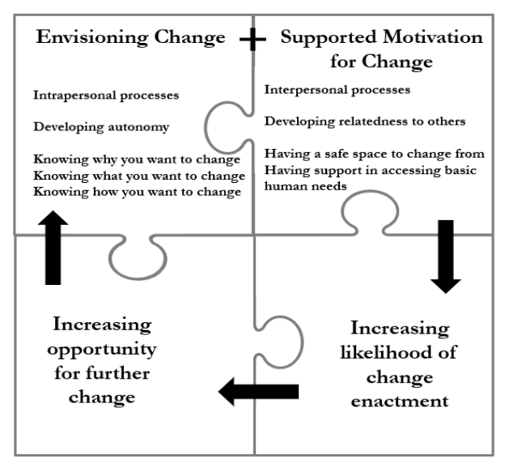
A person needs to visualise what change would mean and how it would look for them. This is a personal process.
With support from others, a person can then develop readiness to make the changes they have begun to imagine. Support from people with lived experience is key. Connecting with supportive others increases motivation and the likelihood change will happen.
Success in making one change increases motivation, opportunities and the ability to visualise more changes. A positive cycle of change can then develop.

What does this mean?

- Motivation for change is not only individual: People need support to develop their readiness to change, whatever changes they want to make. Without a support network that can help them overcome psychological and physical barriers to change, a person will have limited motivation.

- Giving people choice and autonomy is important to develop readiness to change. For example, decisions about which changes to make (or not) should be respected. Understanding people’s values can be part of increasing autonomy. Motivational interviewing is also likely to be helpful – this is an approach that respects the choices that somebody wants to make and helps develop readiness to make changes.

- Relationships between organisations supporting people and the people accessing them should be person-centred, respectful and compassionate. This will increase the likelihood of readiness to change.

- Organisations imposing or demanding change is not likely to ever be helpful. For example, insisting people stop using substances to gain other support damages relationships between staff and people using services.

- Change may be a slow process, that requires consistent supportive relationships. However, when change does happen, it makes it more likely other change will follow.

What future research might be needed?

- Most people interviewed were men. Future research is needed to find out whether there are differences for women, given experiences of SMD can be very different for women to men. Research with individuals from minority groups who were not in the sample would also be helpful.

- Everybody interviewed was receiving support. Research with people who are not being supported by services, and those who have made fewer changes, would be helpful to understand how readiness for change might develop for them.

Want to find out more?

The full research report can be found here:
https://repository.lincoln.ac.uk/articles/thesis/Readiness_for_Change_in_people_living_with_Severe_and_Multiple_Disadvantage/28335242?file=52106003
If you are interested in knowing more about this research project please contact Anna Tickle (Anna.Tickle@frameworkha.org)

